|  |  |  |  |  |  |
| --- | --- | --- | --- | --- | --- |
| Date | 29-Nov-22 | | | Tester Name | Andrew McLaughlin |
| Environment | Penfax - Test | | | Login used |  |
| Operating System | Select OS | Version: | Update: | | |
| Software Used | Select Software | Version: | Update: | | |
| Select Software | Version: | Update: | | |
| Release version | 22.4.1 | | | | |
| Title | Death – Joint Life and One Beneficiary | | | | |
| Test Type | Regression | | | | |
| Test Scenario | Death – Joint Life and One Beneficiary | | | | |
|  |  | | | | |
| Expected Results | When a pensioner dies with a joint annuitant, their payments should be paid out 100% until the end of the guarantee period and then switch to the option they selected.   * We should be able to transfer the lifetime income benefit to the joint annuitant with an expiration date equal to the guarantee period at which point it reverts to the option selected at retirement. | | | | |
| Pass/Fail | Pass | | | JIRA# | N/A |

Describe your steps with screenshots:

Member has a single beneficiary 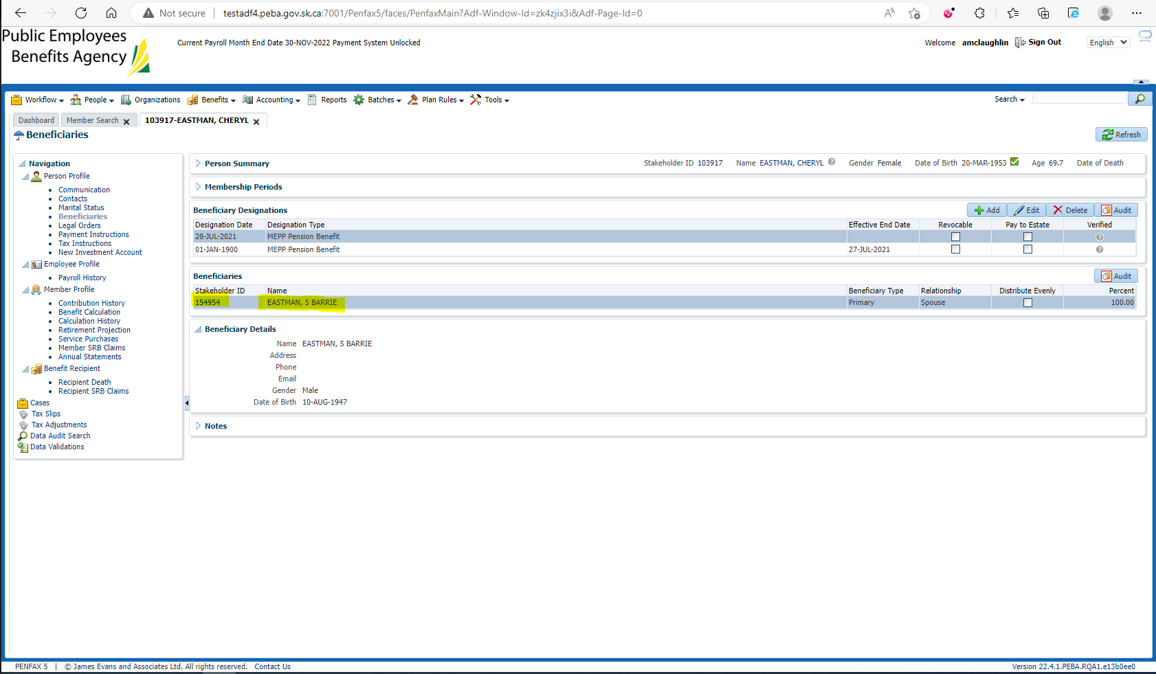

Pension amount is $2,859.58 60%@5 Years 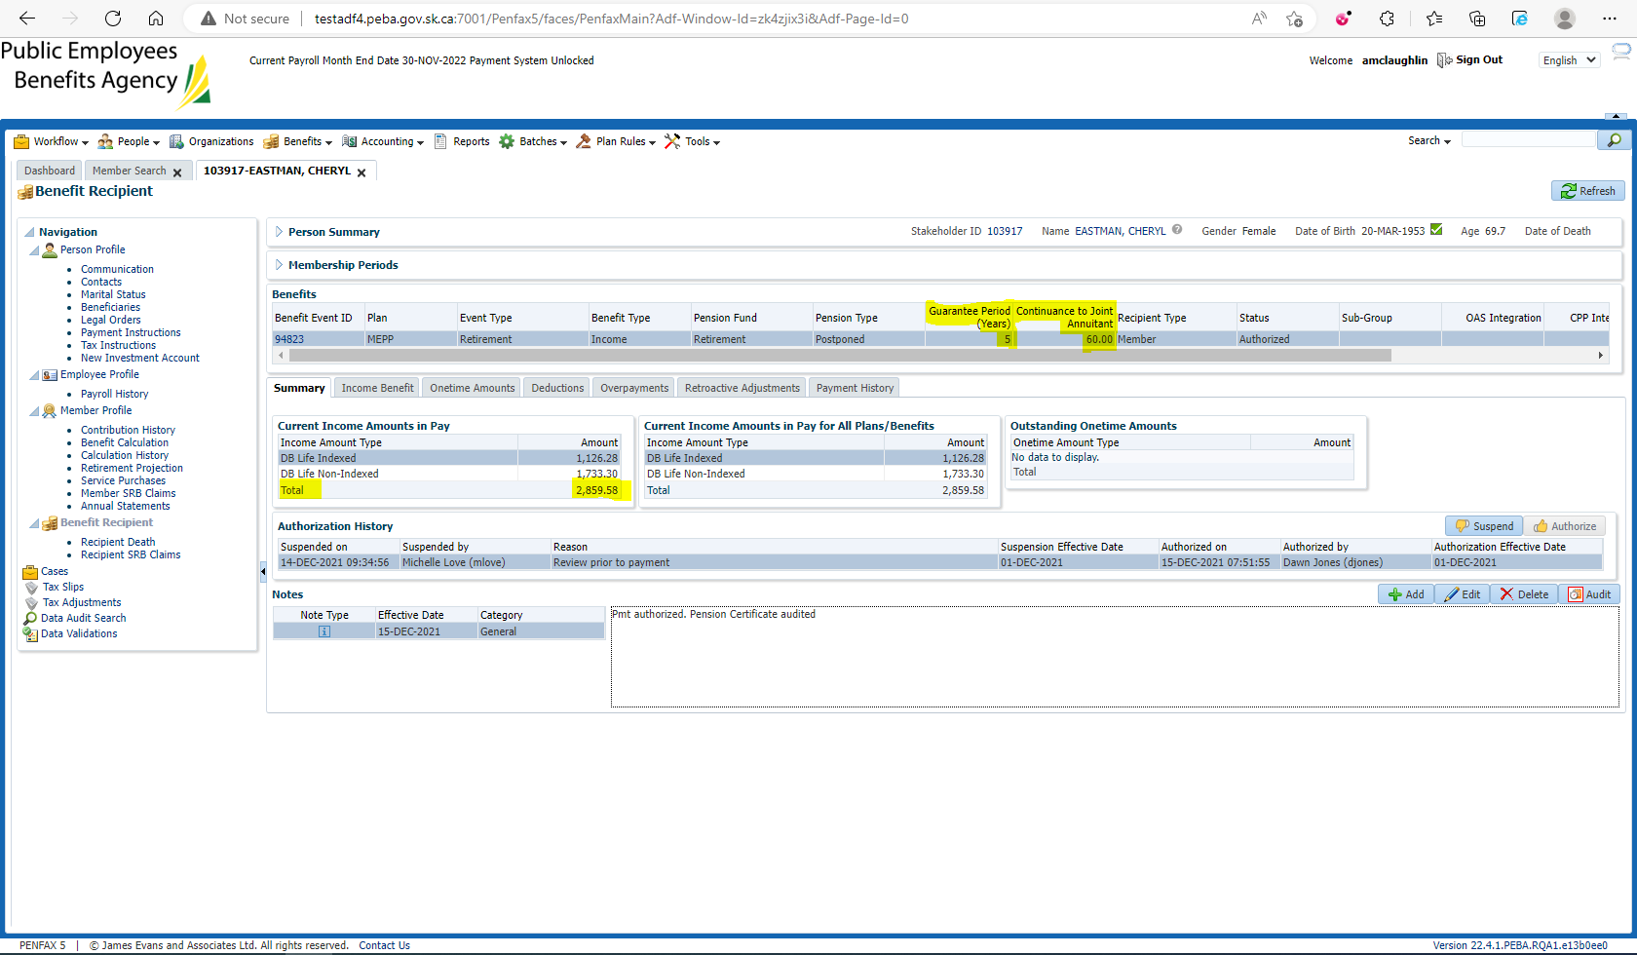

Enter Death Date 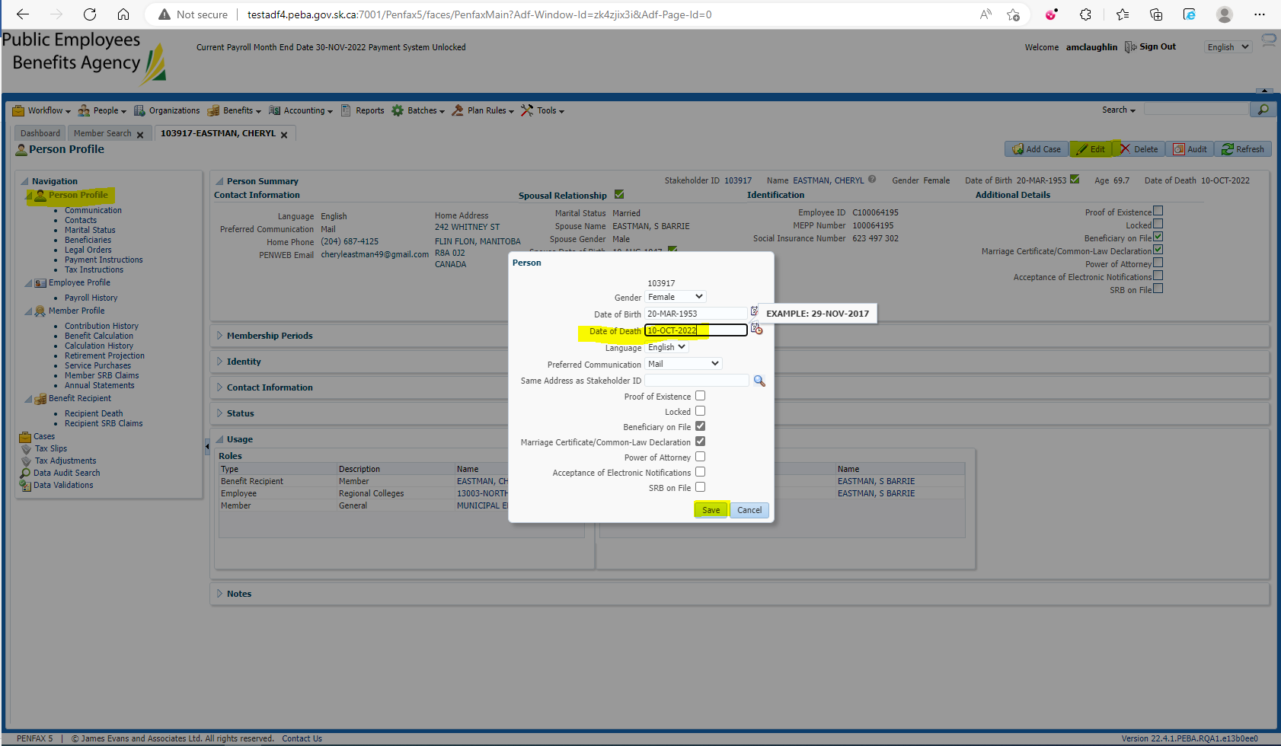

Add the beneficiary to the Benefit Recipients in the Benefit Event effective 1st day of month after death 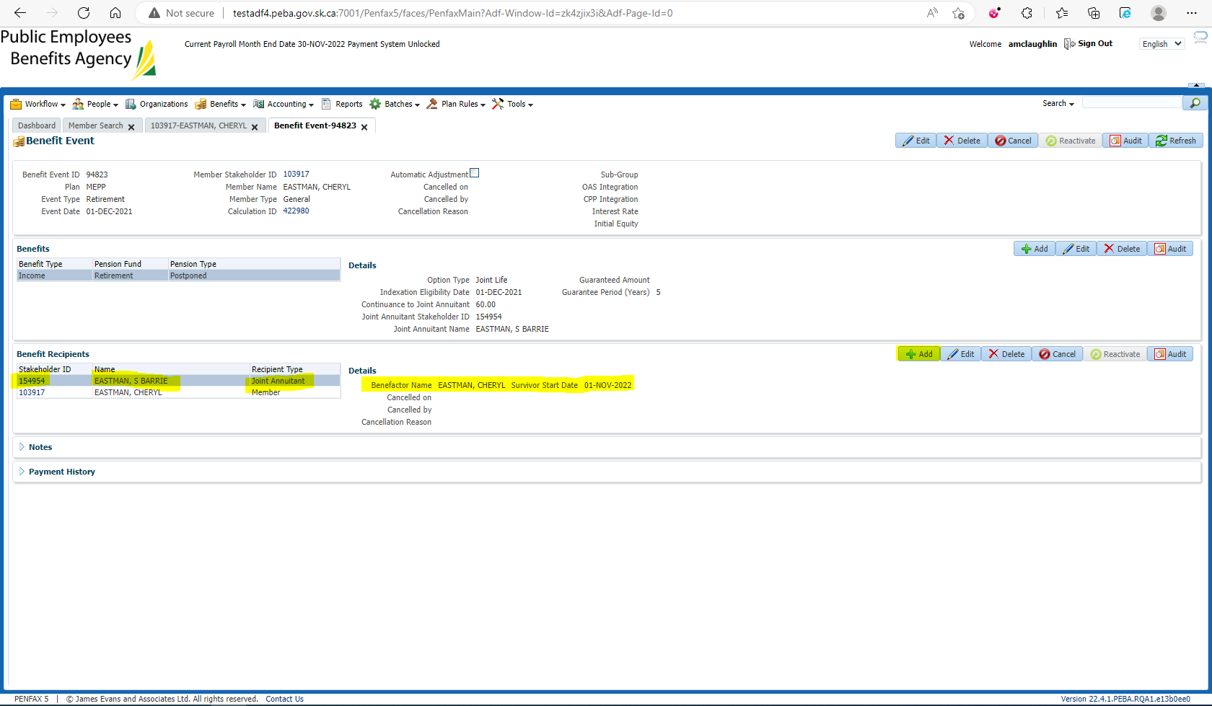

Open the Death Calc 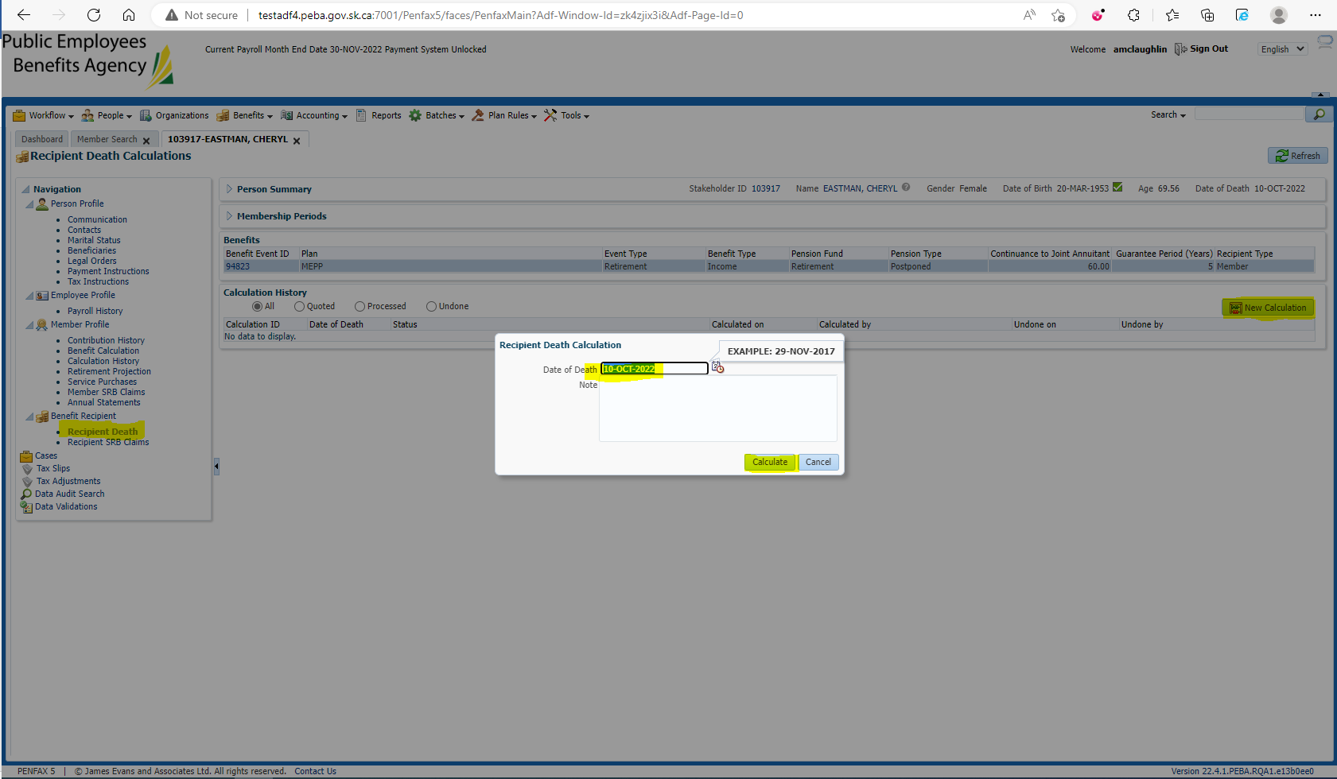

Process x2 and Process Recipient 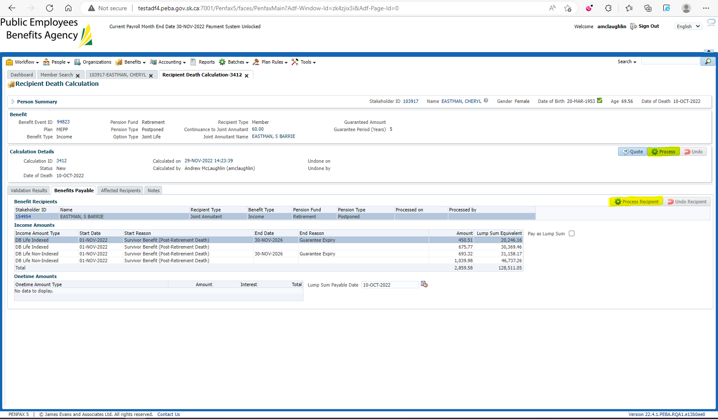

Verify under the beneficiary’s Benefit Recipient that the pension amount is correct 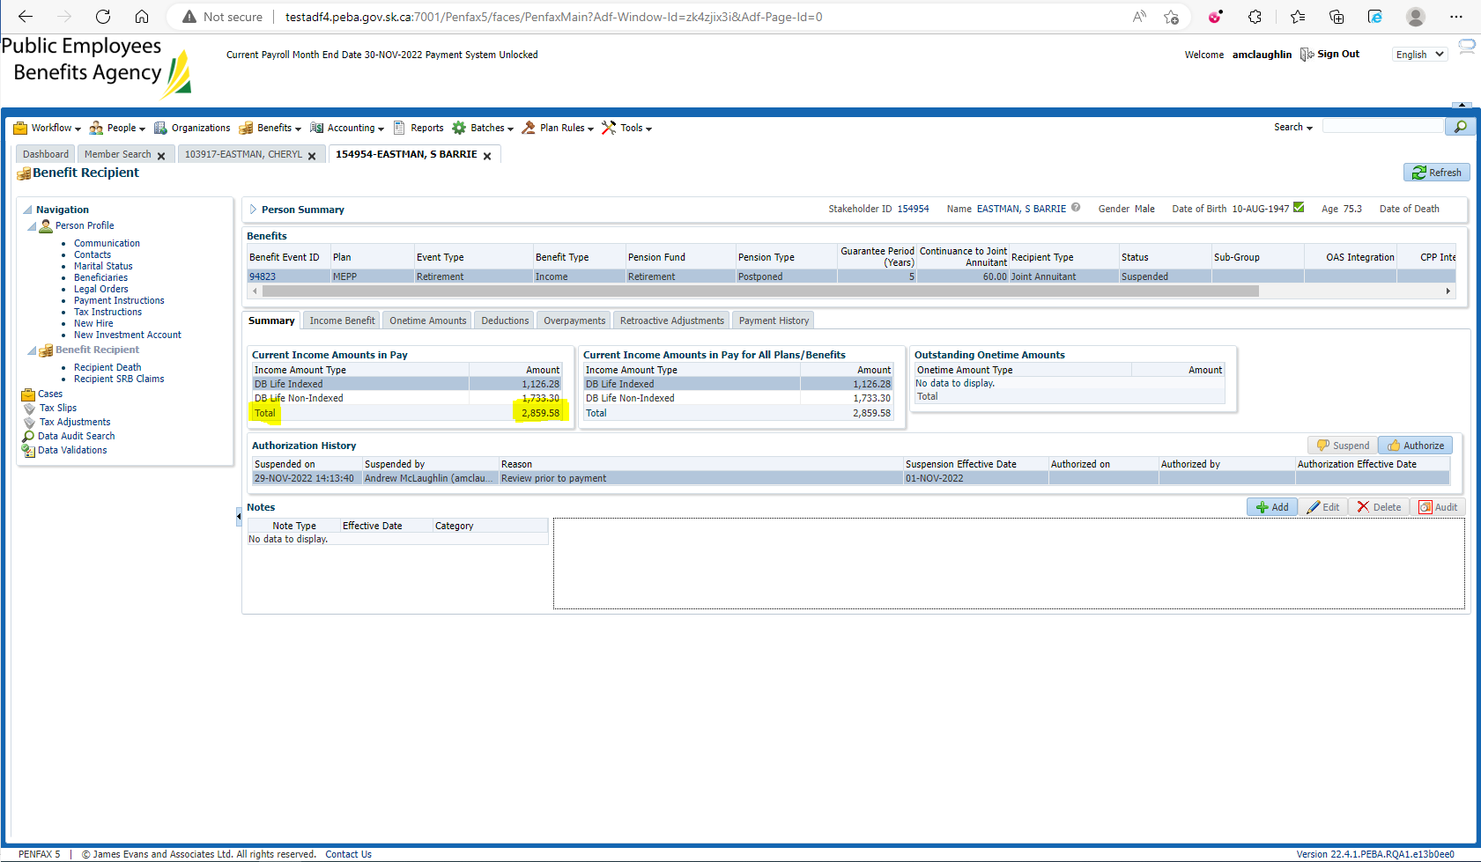

$2,859.58 = $2,859.58